XLPE電纜-XLPE Power Cable
2kV交連聚乙烯電力電纜
2kV XLPE Power Cable
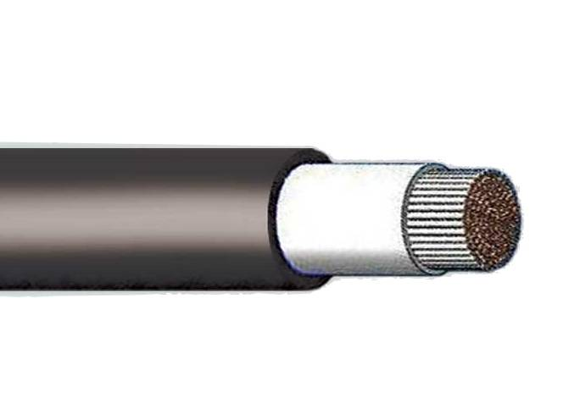
JACKET_PVC
CONDUCTOR_BARE COPPER
INSULATION_XLPE

Construction:

Conductor | min. Average insulation  thickness | min. average  Jacket  thickness | Overall diameter  (approx.) | AC test  voltage | max. Conductor resistance 20℃ | min. Insulation  Resistance 20℃ | Weight  (approx.) | Length
sq. mm | mm. | mm. | mm. | kV/5min | ohm/km | MΩ-km | Kg/km | m
2.0 | 1.14 | 0.38 | 7.3 | 5.5 | 9.24 | 3500 | 56 | 300
3.5 | 1.14 | 0.38 | 7.9 | 5.5 | 5.20 | 3000 | 74 | 300
5.5 | 1.14 | 0.38 | 8.4 | 5.5 | 3.33 | 2500 | 98 | 300
8 | 1.40 | 0.38 | 9.6 | 7.0 | 2.31 | 2500 | 133 | 300
14 | 1.40 | 0.76 | 11.6 | 7.0 | 1.30 | 2000 | 200 | 300
22 | 1.40 | 0.76 | 12.8 | 7.0 | 0.824 | 2000 | 284 | 300
30 | 1.40 | 0.76 | 14.3 | 7.0 | 0.623 | 1500 | 350 | 300
38 | 1.65 | 0.76 | 15.6 | 8.0 | 0.487 | 1500 | 451 | 300
50 | 1.65 | 1.14 | 17.6 | 8.0 | 0.378 | 1500 | 570 | 300
60 | 1.65 | 1.14 | 18.6 | 8.0 | 0.303 | 1500 | 690 | 300
80 | 1.65 | 1.14 | 20.1 | 8.0 | 0.229 | 1000 | 880 | 300
100 | 1.65 | 1.14 | 21.6 | 8.0 | 0.180 | 1000 | 1098 | 300
125 | 1.90 | 1.65 | 24.6 | 9.5 | 0.144 | 1000 | 1400 | 300
150 | 1.90 | 1.65 | 26.3 | 9.5 | 0.118 | 1000 | 1692 | 300
200 | 1.90 | 1.65 | 28.4 | 9.5 | 0.0922 | 800 | 2111 | 300
250 | 1.90 | 1.65 | 30.9 | 9.5 | 0.0722 | 800 | 2669 | 200
325 | 2.29 | 1.65 | 34.4 | 11.5 | 0.0565 | 800 | 3391 | 200
400 | 2.29 | 1.65 | 37.1 | 11.5 | 0.0454 | 800 | 4154 | 200
500 | 2.29 | 1.65 | 39.7 | 11.5 | 0.0373 | 800 | 4996 | 150

XLPE電纜-XLPE Power Cable
600V交連聚乙烯電力電纜
600V XLPE Power Cable
JACKET_PVC
CONDUCTOR_BARE COPPER
INSULATION_XLPE

Construction:

Conductor | min. Average insulation  thickness | min. average  Jacket  thickness | Overall diameter  (approx.) | AC test  voltage | max. Conductor resistance 20℃ | min. Insulation  Resistance 20℃ | Weight  (approx.) | Length
sq. mm | mm. | mm. | mm. | kV/5min | ohm/km | MΩ-km | Kg/km | m
1.6 | 0.76 | 0.38 | 4.2 | 3.5 | 8.92 | 2500 | 49 | 300
2.0 | 0.76 | 0.38 | 4.3 | 3.5 | 5.65 | 2000 | 63 | 300
2.6 | 0.76 | 0.37 | 4.9 | 3.5 | 3.35 | 2000 | 87 | 300
3.5 | 0.76 | 0.38 | 5.0 | 3.5 | 5.20 | 2000 | 71 | 300
5.5 | 0.76 | 0.38 | 5.6 | 3.5 | 3.33 | 2000 | 94 | 300
8 | 1.14 | 0.38 | 6.6 | 5.5 | 2.31 | 1500 | 134 | 300
14 | 1.14 | 0.76 | 8.6 | 5.5 | 1.30 | 1500 | 203 | 300
22 | 1.14 | 0.76 | 9.8 | 5.5 | 0.824 | 1500 | 288 | 300
30 | 1.14 | 0.76 | 10.7 | 5.5 | 0.623 | 1000 | 358 | 300
38 | 1.40 | 0.76 | 12.1 | 7.0 | 0.487 | 1000 | 450 | 300
50 | 1.40 | 1.14 | 14.6 | 7.0 | 0.378 | 1000 | 566 | 300
60 | 1.40 | 1.14 | 15.6 | 7.0 | 0.303 | 1000 | 679 | 300
80 | 1.40 | 1.14 | 17.0 | 7.0 | 0.229 | 1000 | 869 | 300
100 | 1.40 | 1.14 | 18.5 | 7.0 | 0.180 | 800 | 1083 | 300
125 | 1.65 | 1.65 | 21.8 | 8.0 | 0.144 | 800 | 1396 | 300
150 | 1.65 | 1.65 | 23.4 | 8.0 | 0.118 | 800 | 1676 | 300
200 | 1.65 | 1.65 | 25.5 | 8.0 | 0.0922 | 800 | 2091 | 200
250 | 1.65 | 1.65 | 28.0 | 8.0 | 0.0722 | 600 | 2665 | 200
325 | 2.03 | 1.65 | 31.4 | 10.0 | 0.0565 | 600 | 3380 | 200
400 | 2.03 | 1.65 | 34.1 | 10.0 | 0.0454 | 600 | 4147 | 200
500 | 2.03 | 1.65 | 36.8 | 10.0 | 0.0373 | 600 | 4990 | 150
600 | 2.41 | 2.41 | 38.5 | 10.0 | 0.0304 | 600 | 6105 | 150
800 | 2.41 | 2.41 | 46.9 | 10.0 | 0.0234 | 400 | 7883 | 150
1000 | 2.41 | 2.41 | 52.1 | 10.0 | 0.0179 | 400 | 10160 | 150

